**CHAPTER 8 SOLUTIONS**

* 1. The binomial probability model may not be used for this situation. Because the person studied, the probability of success from question to question will not be constant.
  2. The binomial probability model may not be used for this situation. There are three, not two, possible outcomes.
  3. The binomial probability model may be used for this situation. The probability of exactly 50 imperfections in 500 trials is .059.
  4. The binomial probability model may be used for this situation. The probability of exactly 1 girl in three births is .375.
  5. The binomial probability model may be used for this situation. Probabilities are given to 3 decimal places, where appropriate.

a) .056 b) .250 c) 0005 d) 0005 e) .922 f) .736

* 1. The binomial probability model may be used for this situation. The probability of selecting 5 schools from the Northeast out of 10 schools is .0328.
  2. The binomial probability model may not be used for this situation. The probability of correct installation is not constant from trial to trial.
  3. The binomial probability model may be used for this situation. The probability of at least one false positive result in 10 mammograms is .491.
  4. Answers are given to two decimal places.

a) .25

b)  .43

c)  .68

d) .75

e) .99

f)  .08

g)  .10

h) .99

* 1. Answers have been rounded to three decimal places.

a) .001

b) .246

* 1. Solution 1 is incorrect because the outcomes listed are not equally likely. Solution 2 is correct.
  2. False. The probability of obtaining 5 heads in 10 tosses of a fair coin is .2461, while the probability of obtaining 2 heads in 4 tosses is .375.

a)

*k* *p*

0 .016

1 .094

2 .234

3 .312

4 .234

5 .094

6 .016

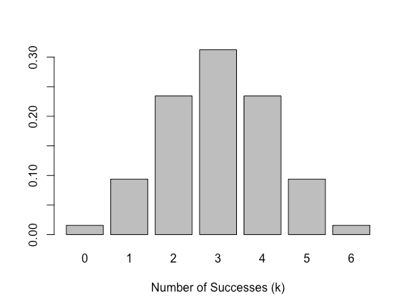b) The distribution is symmetric.

c) The mean is 3 and the standard deviation is 1.225.

1. .09
2. .98
3. .91
4. .02
5. .89
6. .26
7. .26
8. .69
9. .52
10. -.39
11. -.52
12. .39

a) .023

b) .023

c)  .046

d) .954

a) .016

b)  .395

c)  .052

d) .903

a) 1.2

b) -.37

c)  -.42

1. .02
2. .84
3. .98
4. .16
5. .82
6. .14
7. .14
8. .32
9. 62.8.
10. 37.2.
11. 62.8.
12. 37.2.

a) 58.55

b)  91.45

c)  .067

d) .067

e)  .383

f)  .006

g) .625

a) *z* = 1.645

b)  *z* = 1.960

c)  *z* = 2.576

a) .175

b)  .309

c)  .841

Using R: 130.81. Using Table 1: 130.75.

a) 990 days.

b)  Approximately 1 percent.

a) 80.8 or 81 people

b)  65.54 percent or .655

c)  56.4

a) .933

b)  .933 or 93.3 percent

* 1. Using the normal distribution, we estimate that the percentage of students in the NELS data set with eighth grade math achievement scores greater than or equal to 72 is 95.1 percent. The actual percentile rank of 72 is 94.2 percent. The value based on the normal distribution (95.1) provides a reasonably good approximation of the one based on the actual distribution (94.2) and suggests, in this case, that the normal curve is reasonably appropriate for approximating the distribution of eighth grade math achievement scores.
  2. Using the normal probability model, we estimate that the number of students in the NELS data set with eighth grade math achievement scores that are within one standard deviation of the mean is approximately 341 (approximately 68.27 percent). In fact, there are only actually 311 such students. Given the discrepancy between these two values (of approximately ten percent), it appears that eighth grade achievement scores are not as well approximated by a normal distribution as one might think from the previous exercise.
  3. The *z*-score associated with offering 6 AP courses is .09. Using Table 1, we expect approximately 46.41 percent of the scores to have a z-score of .09 or more. Of the 473 students in the NELS data set for which the variable was measured, we would, therefore, expect approximately 220 to come from schools offering 6 or more AP courses. According to the frequency distribution table, only 186 students actually come from schools offering 6 or more AP courses. This discrepancy is probably because the distribution of apoffer is severely positively skewed (skewness ratio = 36.34), so it is not well approximated by the normal distribution. The histogram with normal curve overlay is created using the following R commands:

**apoffer2 = na.omit(NELS$apoffer)**

**x = seq(min(apoffer2), max(apoffer2), length = 100)**

**hx = dnorm(x, ap.mean, ap.sd)**

**hist(apoffer2, breaks = 20, freq = F, xlab = "Number Advanced Placement Courses Offered by School", main = "")**

**lines(hx~x)**

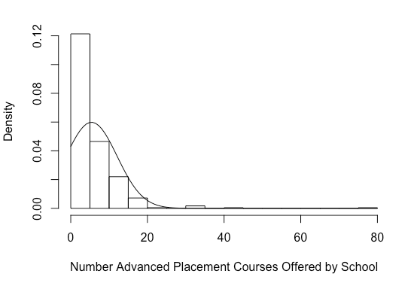

1. The distribution of supportc is approximately normally distributed. The histogram with normal curve overlay is created using the following R commands:

**x = seq(min(Impeach$supportc), max(Impeach$supportc), length = 100)**

**hx = dnorm(x, mean(Impeach$supportc), sd(Impeach$supportc))**

**hist(Impeach$supportc, breaks = 15, freq = F, xlab = "State Voter Support for Clinton", main = "")**

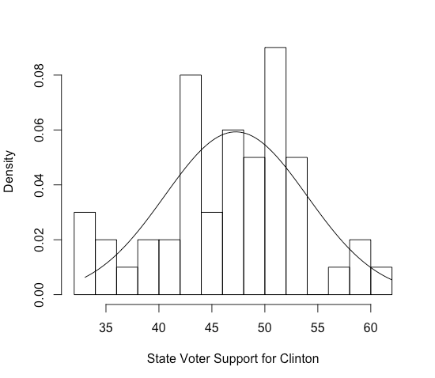**lines(hx~x)**

b) 56.004

c) -1.82

d) .034

e) According to the cumulative percent column, it’s 8 percent.

f) .034 or 3.4 percent

g) .1249

h) .8751

i) .8409

j) 43.73

k) 58.32

l) 47.26

a) .5822

b) *np* = (20)(.5) = 10 and *nq* = (20)(.5) = 10. Both of these values are greater than 5, as required.

c)  and 

d) .5815